DISCUSSION PROCEEDINGS TEMPLATE

NAM Discussion Proceedings

Community-Based Models of Care Delivery for People with Serious Illness: A Literature Review

Month Day, Year

Background Information
Persons with serious illness and their families have medical, psychosocial, and spiritual needs to be met in the community setting. High-quality programs share common foundational elements necessary to match services to population needs. The authors of this paper will first describe guiding principles that are inherent to the ideal community-based model program (see Box 1), and then discuss core competencies that these programs must possess to provide high-quality care.

Meeting Summary
Day 1
Mr. Bhusan Dahal, Nepal journalist, and Dr. Rabindra Prasad Dhakal, NAST, welcomed attendees and described the workshop objectives.

Building on the work of others, the authors of this paper have identified key principles that should guide the development of community-based serious illness care programs (Lowy and Collins, 2016).

Theme 1 Session: Interconnected Realities: The Political Economy of Climate and Health
Dr. Popular Gentle, Office of Prime Minister and Council of Ministers, Nepal, and Dr. Victor Hoe, University of Malaysia, discussed the political economy of climate and health.

First and foremost, serious illness care programs should be driven by the priorities and goals of the person and family (Herbert et al., 2013). Accommodation should be made to tailor services that are culturally responsive and language-concordant, as shown in Figure 2. The program should support the family unit as defined by the person (Lowy and Collins, 2016; Herbert et al., 2013). Person- and family-centeredness should continue through the end of life and include bereavement supports for the family and others close to the person who has died (see Table 1).

Areas of Future Focus or Key Themes
Author Name, MD, Affiliation; Author Name, PhD, Affiliation; and Author Name, MD, PhD, Affiliation

The discussions at this workshop highlighted several critical areas of future focus and key themes essential for addressing the intertwined challenges of climate change, health, and equity in South and Southeast Asia

Conclusion
The discussions at this workshop highlighted that addressing the climate and health crisis in South and Southeast Asia requires a multifaceted approach that integrates scientific research, innovative solutions, community engagement, and robust policy frameworks. A key challenge is the need for increased funding targeting the intersection of climate and health, as current funding streams remain siloed. Funders must promote transdisciplinary work that can support integrated solutions.

References
- Hebert, L. E., J. Weuve, P. A. Scherr, and D. A. Evans. 2013. Alzheimer disease in the United States (2010-2050) estimated using the 2010 census. Neurology 80:1778-1783. https://doi.org/ 10.1212/WNL.0b013e31828726f5.
- Lowy, D. R., and F. S. Collins. 2016. Aiming high—changing the trajectory for cancer. New England Journal of Medicine I374:1901-1904. https://doi.org/10.1056/NEJMp1600894.

Disclaimer
This Discussion Proceedings was prepared by RAPPORTEUR NAME, RAPPORTEUR NAME, and RAPPORTEUR NAME as a factual summary of what occurred at the meeting and areas of future focus and key themes. The statements made are those of the rapporteurs or individual meeting participants and do not necessarily represent the views of all meeting participants; the planning committee; members of the associated program; the National Academy of Medicine; or the National Academies of Sciences, Engineering, and Medicine.

Reviewers
To ensure that it meets institutional standards for quality and objectivity, this Discussion Proceedings was reviewed by REVIEWER NAME, REVIEWER INSTITUTION and REVIEWER NAME, REVIEWER INSTITUTION.

Sponsors
This workshop was supported by contracts between SPONSOR and the National Academy of Medicine (or) by support from SPONSOR. Any opinions, findings, or conclusions expressed in this publication do not necessarily reflect the views of any organization or agency that provided support for the project.
OR: This workshop was held in collaboration with ORGANIZATION. Any opinions, findings, or conclusions expressed in this publication do not necessarily reflect the views of any organization or agency that assisted in the development of this project.

For additional information, please visit LINK TO MEETING PAGE.

DOI
https://doi.org/10.31478/xxxx

Suggested Citation
Bee, J., J. Cabbage, and C. Linell, rapporteurs. 2017. Community-based models of care delivery for people with serious illness: A literature review. NAM Perspectives. Discussion Proceeding, National Academy of Medicine, Washington, DC. https://doi.org/10.31478/xxxx.

SAMPLE BOX, FIGURE, AND TABLE

Sample box

Box 1 | Priorities for Action

Create incentives for clinician engagement

- Align priorities.
- Engage clinicians as active partners in the design and conduct of learning activities.
- Allow engagement in knowledge generation to satisfy existing professional obligations.
- Generate actionable, timely, and relevant knowledge [a].

Address productivity pressure

- Minimize the competing demands placed on clinicians and embed knowledge generation into work flow.
- Address the misalignment in financial compensation.

SOURCE: Reprinted with permission from the Robert Wood Johnson Foundation.
NOTES: [a] Institute of Medicine. 2013. Best Care at Lower Cost: The Path to Continuously Learning Health Care in America. Washington, DC: The National Academies Press. https://doi.org/10.17226/13444.

Sample figure

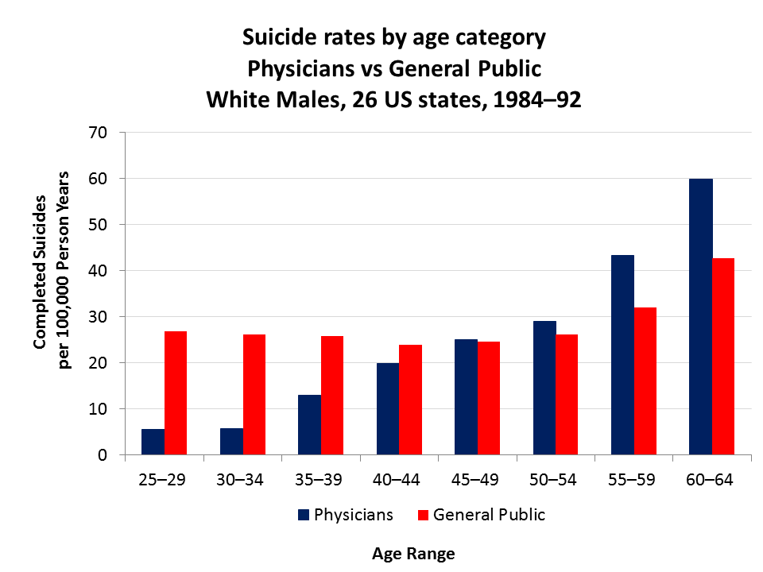
Figure 1 | Suicide Rates by Age Category Among Physicians and the General Population
SOURCE: National Academies of Sciences, Engineering, and Medicine. 2019. Taking Action Against Clinician Burnout: A Systems Approach to Professional Well-Being. Washington, DC: The National Academies Press. https://doi.org/10.17226/25521.
NOTE(S): Suicide rates for other health professionals are also higher than that of the general population.

Sample table

 | Count | % of U.S. Total Population
1 or More Race | 4.5 million | 1.4
AIAN Only [a] | 3 million | 1.2
Projected in 2016—1 or More Race | 10 million | 2.0
2016—AIAN Only | 5 million | 1.3
0-15 Years Old in 2014 | 1.1 million | 1.87
Live Births 2013 | 45,000 | 1.17

Table 1 | U.S. American Indian and Alaska Native Demographic Data
SOURCE: Reprinted with permission from the Centers for Disease Control and Prevention.
NOTE(S): [a] AIAN = American Indian/Alaska Native.

