**DISCUSSION PAPER TEMPLATE**

**Discussion Paper**

**Community-Based Models of Care Delivery for People with Serious Illness:** A Literature Review

**Jeffrey Cohn, MD, MHCM,** Common Practice; **Janet Corrigan, PhD, MBA,** Gordon and Betty Moore Foundation; and **Joanne Lynn, MD,** Altarum Institute

April 13, 2022

*ABSTRACT:**The 20th century saw remarkable improvements in life expectancy. Improvements in access to clean water, disease screening and prevention, the discovery of antibiotics and vaccines, development of organ transplantation, and advances in treatment for heart disease and cancer have all contributed to an expectation that Americans will live long lives in generally good health. A concomitant change has been that most Americans will now experience a substantial period of living with serious illness, mostly progressive and life-limiting. An estimated 45 million Americans are living with one or more chronic conditions that limit personal function and are likely to worsen rather than get better. Although representing only 14 percent of the population, these seriously ill persons account for 56% of all health care expenditures—almost $1 trillion.*

**Guiding Principles and Competencies**

Persons with serious illness and their families have medical, psychosocial, and spiritual needs to be met in the community setting. High-quality programs share common foundational elements necessary to match services to population needs. The authors of this paper will first describe guiding principles that are inherent to the ideal community-based model program (see *Box 1*), and then discuss core competencies that these programs must possess to provide high-quality care.

**Guiding Principles**

Building on the work of others, the authors of this paper have identified key principles that should guide the development of community-based serious illness care programs (Lowy and Collins, 2016).

*Person-Centered Care*

First and foremost, serious illness care programs should be driven by the priorities and goals of the person and family (Herbert et al., 2013). Accommodation should be made to tailor services that are culturally responsive and language-concordant, as shown in *Figure 2*. The program should support the family unit as defined by the person (Lowy and Collins, 2016; Herbert et al., 2013). Person- and family-centeredness should continue through the end of life and include bereavement supports for the family and others close to the person who has died (see *Table 1*).

**References**

Hebert, L. E., J. Weuve, P. A. Scherr, and D. A. Evans. 2013. Alzheimer disease in the United States (2010-2050) estimated using the 2010 census. *Neurology* 80:1778-1783. https://doi.org/ 10.1212/WNL.0b013e31828726f5.

Lowy, D. R., and F. S. Collins. 2016. Aiming high—changing the trajectory for cancer. *New England Journal of Medicine* I374:1901-1904. https://doi.org/10.1056/NEJMp1600894.

**DOI**

https://doi.org/10.31478/202202a

**Suggested Citation**

Cohn, J., J. Corrigan, and J. Lynn. 2017. Community-based Models of Care Delivery for People with Serious Illness: A Literature Review. *NAM Perspectives.* Discussion Paper, National Academy of Medicine, Washington, DC. https://doi.org/10.31478/202202a.

**Author Information**

**Jeffrey Cohn, MD, MCHM,** is President, Common Practice. **Janet Corrigan, PhD, MBA,** is Vice President, Gordon and Betty Moore Foundation. **Joanne Lynn, MD,** is Director, Altarum Institute.

The authors are members of the Roundtable on Quality Care for People with Serious Illness at the National Academies of Sciences, Engineering, and Medicine.

**Acknowledgments**

**Linda George,** **PhD,** Senior Program Officer at the National Academies of Sciences, Engineering, and Medicine, provided valuable support for this paper.

**Conflict-of-Interest Disclosures**

Dr. Cohn discloses serving on the board of the American Association of Family Physicians.

**Correspondence**

Questions or comments should be directed to Jeffrey Cohn at jcohn@commonpractice.org.

**Sponsor(s)**

This work was conducted with the support of the Ford Foundation.

**Disclaimer**

The views expressed in this paper are those of the authors and not necessarily of the authors’ organizations, the National Academy of Medicine (NAM), or the National Academies of Sciences, Engineering, and Medicine (the National Academies). The paper is intended to help inform and stimulate discussion. It is not a report of the NAM or the National Academies. Copyright by the National Academy of Sciences. All rights reserved.

**SAMPLE BOX, FIGURE, AND TABLE**

**Sample box**

**Box 1 | Priorities for Action**

**Create incentives for clinician engagement**

* Align priorities.
* Engage clinicians as active partners in the design and conduct of learning activities.
* Allow engagement in knowledge generation to satisfy existing professional obligations.
* Generate actionable, timely, and relevant knowledge [a].

**Address productivity pressure**

* Minimize the competing demands placed on clinicians and embed knowledge generation into work flow.
* Address the misalignment in financial compensation.

**SOURCE:** Reprinted with permission from the Robert Wood Johnson Foundation.

**NOTES:** [a] Institute of Medicine. 2013. *Best Care at Lower Cost: The Path to Continuously Learning Health Care in America.* Washington, DC: The National Academies Press. https://doi.org/10.17226/13444.

**Sample figure**

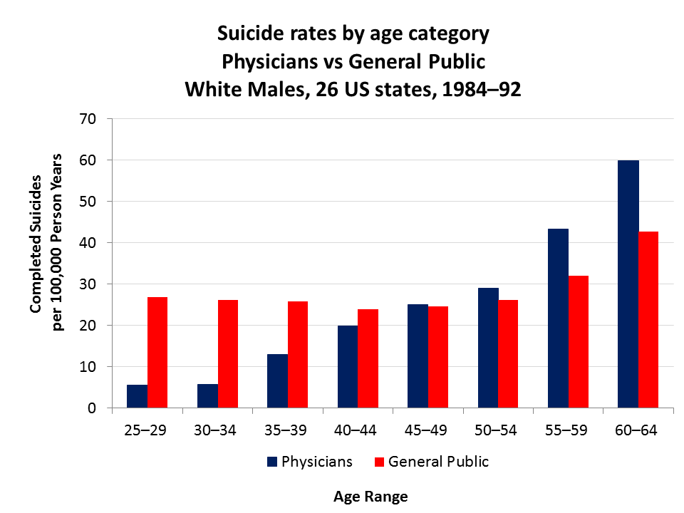

**Figure 1 | Suicide Rates by Age Category Among Physicians and the General Population**

SOURCE: National Academies of Sciences, Engineering, and Medicine. 2019. *Taking Action Against Clinician Burnout: A Systems Approach to Professional Well-Being.* Washington, DC: The National Academies Press. https://doi.org/10.17226/25521.

NOTE(S): Suicide rates for other health professionals are also higher than that of the general population.

**Sample table**

|  |  |  |
| --- | --- | --- |
|  | **Count** | **% of U.S. Total Population** |
| **1 or More Race** | 4.5 million | 1.4 |
| **AIAN Only** [a] | 3 million | 1.2 |
| **Projected in 2016—1 or More Race** | 10 million | 2.0 |
| **2016—AIAN Only** | 5 million | 1.3 |
| **0-15 Years Old in 2014** | 1.1 million | 1.87 |
| **Live Births 2013** | 45,000 | 1.17 |

**Table 1 | U.S. American Indian and Alaska Native Demographic Data**

SOURCE: Reprinted with permission from the Centers for Disease Control and Prevention.

NOTE(S): [a] AIAN = American Indian/Alaska Native.